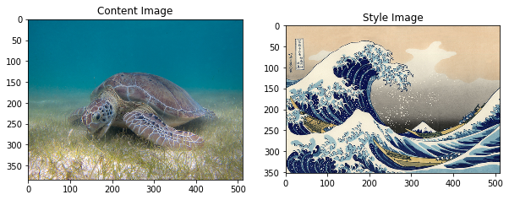
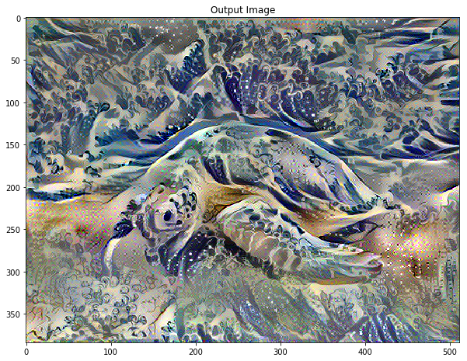
For alpha=10e3 beta=10e-2 iterations=1000
NEURAL STYLE TRANSFER

best total content+style loss=1339072.0

